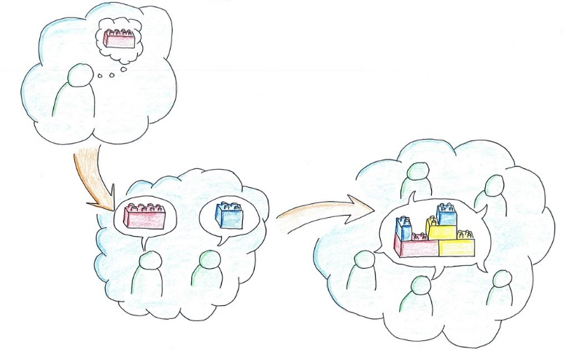
Name:

THINK-PAIR-SHARE

Topic: The Pressure to Succeed
PROMPT | What I think | What my partner/group thought | What we shared
After reading and viewing the lesson materials, what sort of pressure to do well in university do you observe in your own life?
Is there a particular career you would like to pursue, that places a high amount of pressure on you to do well in school?
Do you feel under pressure to avoid disappointing your loved ones if you do not do well in school?
Which strategies have you used in the past to deal with stressful academic deadlines?
Are extracurricular activities something you find helpful to do in your free time to relieve stress and the fear of failing?
The pressure to succeed can lead to stress, anxiety, despair, low self-esteem, and lack of confidence. Which beneficial advice from the reading material stood out to you the most regarding overcoming these problems?

